# Security Review Documentation - Form 22-1919 (Conflicting Interests For Proprietary Schools)

## Architecture Diagram

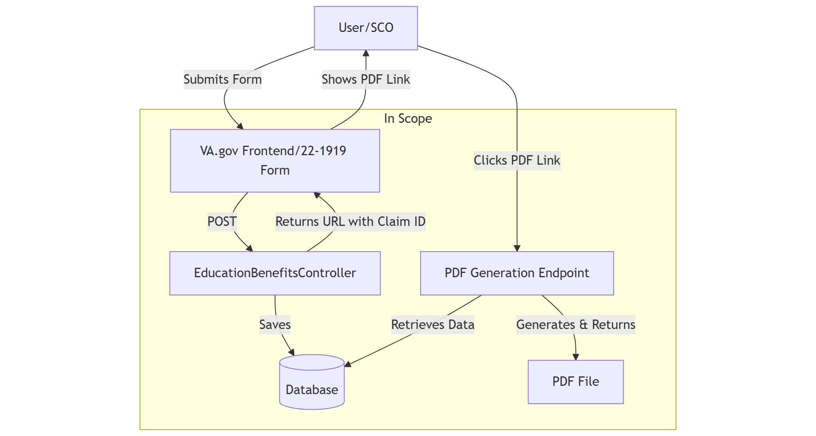

* User submission flow
* Controller interactions
* PDF generation

Security Approach:

* Uses existing education benefits security model
* Standard VA.gov security controls
* Unauthenticated form submission

Dependencies:

* Existing education benefits infrastructure
* Standard VA.gov components

## Incident Response Plan

Points of Contact:

* Primary: VEBT team
* Slack Channels:
  + #vfep-developer-support (main alerts)
  + #vsa-education-logs (additional logging)

Security Fix Timeline:

* Follow standard VA.gov security patch process
* Immediate response to critical vulnerabilities
* Coordination with platform team as needed

## Sequence Diagram

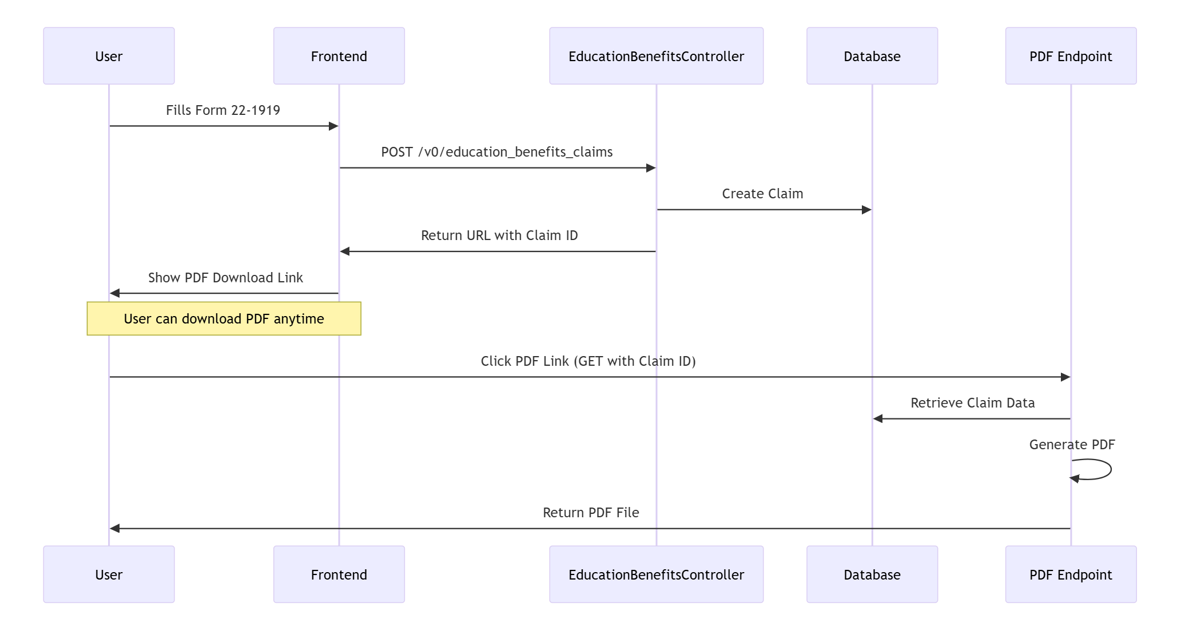

* Form submission flow
* Data storage
* PDF generation process

## Data Flow Diagram

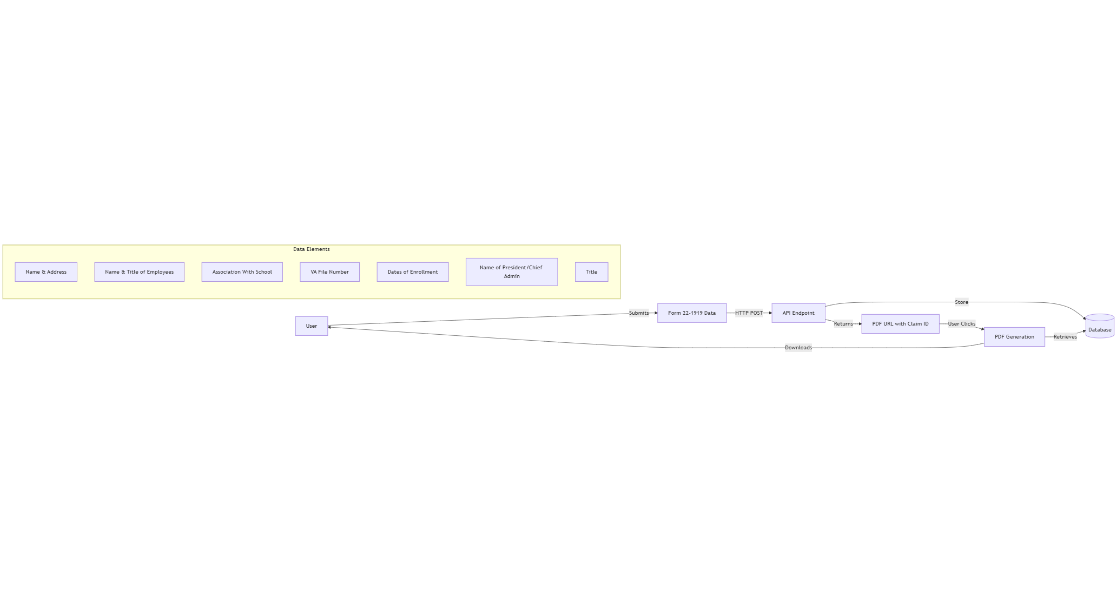

* Data collection points
* Storage locations
* Access patterns
* Processing flow

Data Collection:

* Name & Address
* Name & Title of Employees
* Association With School
* VA File Number
* Dates of Enrollment
* Name of President/Chief Admin
* Title

Data Storage:

* Standard database encryption
* Temporary file storage for PDF files

Access Control:

* Public form submission
* Restricted PDF file access

## API Endpoint Documentation

Endpoint: POST /v0/education_benefits_claims/1919

* Part of existing education benefits claims controller
* Uses same pattern as other education forms (i.e. 22-10203)
* Standard input validation

## Monitoring Plan

Datadog Monitoring:

* Education Benefits Claims dashboard
* P3 monitor for non-4XX errors
* P4 monitor for anomalous traffic

## Security Monitoring Plan

Code Base Security:

1. Compromise Detection
   * Monitored via existing Datadog alerts
   * Abnormal traffic patterns detected by P4 monitor
   * Server errors caught by P3 monitor
2. Process Execution
   * Runs within existing education benefits claims infrastructure
   * Uses same security model as other education forms
   * Authentication not required (public-facing form)
3. Disabling Process
   * Can be disabled via existing education benefits controls

## New Logging

1. Standard Controller Logging:
   * Request/response logging via existing controller
   * Error logging to standard Rails logs

## Cookies

* No new cookies introduced
* Uses standard VA.gov session management
* No modifications to existing cookies

## Authentication Status

* Unauthenticated form (public-facing)
* Same security model as form 22-10203
* No login required for submission

## Release Plan

Phase I - UAT:

1. Planning
   * Test on staging environment
   * Verify Datadog monitoring
   * Confirm alert routing
   * Test PDF generation

Phase II - Limited Release (available if desired):

1. Planning
   * Monitor form submissions in production
   * Review Datadog metrics for errors/issues

Go Live:

1. Planning
   * Full production deployment
   * Active monitoring via Datadog dashboard
   * Alert response via established playbook

## Potential Abuse Scenarios & Mitigation

1. Form Submission Abuse
   * Rate limiting via existing VA.gov controls
   * Input validation on all fields
   * Same protections as other education forms

## Data Storage and Security

1. Database Storage
   * Uses existing education benefits claims tables
   * Standard VA.gov database security
   * Regular data cleanup processes
2. File Storage
   * Temporary PDF file storage
   * Files deleted after PDF generated